SL15 Operator UI

DOC. No.: | REV.: 00 |  |  | PRODUCT:
TITLE: SL15 Operator UI |  |  |  | Project:
Prepared by: | Donald huang |  |  | Date:
Remark: | Approval:
Remark: |  | Department | Title |  |  | Signature
Remark: | 1 | Electronic R&D
Remark: | 2
Remark: | 3
Remark: | 4

Revision | Description of Change | Author | Date
00

1. Introduction 4
1.1. Objective 4
1.2. Scope 4
1.3. Reference 4
1.4. Abbreviations 4
2. Overview 5
2.1. Consideration 5

Introduction

Objective

Purpose of this document is to describe the SL15 graphic display for operator and trained technician. (Customer, operator, trained technician are roles defined in SL15 VMC SW Requirement.doc)

This document not only describes UI for operator menu, but also describes UI for initialization, maintenance, function off, locked, administration, installation, etc. and the UI for PC application.

Scope

The UI described in this document is about user interface shown in the main board LCD screen and PC application connecting to main board.

Reference
SRS GVMC CL 12b.doc
Graphic display.version1.0.doc
Operator menu.version01.doc
SL Operator Menu V4-03_eng.pdf
SL25 ui.doc

SL15 VMC SW Requirement.doc
SL15 Customer UI.doc

Abbreviations

Overview

The operator UI requirement is based on SL series’ operator menu.

New SL customers find the machines too complex. This due to whole army of parameters that are rarely used is placed into the operator menu. People are overwhelmed by these and start to appreciate the flexibility ones they get to know the machine. Unfortunately many customers don’t get to that point and sales are missing.

SL15’s operator UI moves the complex parameters and rarely used functions to PC applications. Only essential functions left in the operator UI.

Major functions

Operator UI

The operator UI is UI for machine in Operator/Service mode (see SL15 VMC SW Requirement.doc), UI for other mode see other UI.

- Parameters
- Price(11)
- Dosage (23??)
- Volume??(relative dosage, not in old system)
- Statistics
- Product Per.(631)
- Product accumulation(632)
- Audit Per.(633)
- Audit accumulation(634)
- Clear Turnover(636)
- Cashbox(635)
- Log/Clear Log(51,52)
- Service
- Refill (283)
- Maintenance(24)
- Test product(293)
- Components(21)
- Others
- Utilities
- Test consumption(8)
- Reset machine(7)
- Password(9)
- Language(15)
- Audit(19)
- Miscellaneous
- Software version(61,281)
- Date/Time(62)
- Learn IR-key (1351, 1352, 1353)

PC application

- Parameters
- Component adjustment(21)
- Recipe(23)
- Preparation(22)
- Test Product(293)
- Machine
- Clock function(141→144)
- Reset machines(7)
- Back office
- Show turnover (BOS/EVA) (cash, irkey, card, etc.)
- Reset (EVA)
- Prices(EVA)
- Init
- switch EVA/BOS
- Vending
- Vend options
- Vend mode(3121)(single/multi vend)
- Price mode(3123)(free/following/holding)
- Mandatory sale(3122)
- Overpay take in(3133)
- Auto start
- Open environment
- Revalue option
- Mix payment option
- Miscellaneous
- Software information(61,281)
- Hardware information(68,285,282)
- Tel number(65)
- Backup data
- Log(51,52)

Others UI
- Installation/Wakeup
- Function off / Standby
- Special vending
- Locked
- Out of order
- Administration

Operator UI

Operator UI and other UI appear on the machine LCD screen. Operators or customers use touch screen to input and select. A virtual number key board or alpha key board will be shown on the screen when numbers or letters need to be inputted.

Each operator UI functions provides individual UI to operator, functions can be accessed by menu and submenu.

Operator UI menus

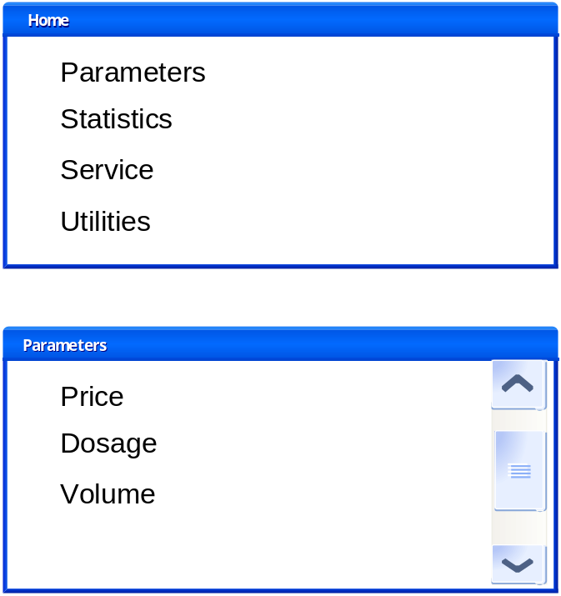

The above figure shows the operator UI menu/submenu windows.

There are 3 major parts of the UI:
- A title bar shows the current menu location
- Menu / submenu items
- A Scrollbar

Parameters
Price

Statistics

Service

Utitles

PC application
When the PC application connects to the machine, it will take over control of the machine and the machine will go to Administration state. The machine will not leave administration state until the PC application disconnects.

Other UI

